

IBM Tivoli DFSMShsm Analysis for
ABC

April 01, 2009

Table of Contents

Executive Summary 3
Background 3
Overview 3
DFSMShsm Analysis 4
Background 4
Availability 4
Importance 4
Risks and Exposures 4
Benefits of IBM Tivoli DFSMShsm Product Solution’s 5
DFSMShsm Summary 6
Migration and Recall Summary 7
Migration and Backup Summary 8
DFSMShsm Tape Utilization 9
DFSMShsm Tape Summary 9
DFSMShsm Financial Overview 10
Defaults 10
DFSMShsm CDS Auditing 11
Using IBM Tivoli Advanced Audit for DFSMShsm 11
MCDS Audit Summary 12
BCDS Audit Summary 13
OCDS Audit Summary 13
Financial Summary 15

Executive Summary

Background
The following document represents the results of the DFSMShsm Analysis performed for ABC on April 01, 2009 on PROD system. This study is provided by IBM Software to identify opportunities for improvement in the DFSMShsm Management areas. The DFSMShsm Analysis was performed using IBM Tivoli Advanced Reporting for DFSMShsm and IBM Tivoli Advanced Audit for DFSMShsm.

The sections that follow show the results of the DFSMShsm Analysis in detail. It should be noted that all of the data in this report represents a high-level picture of the DFSMShsm environment. There may be instances where CPU, I/O and Media cannot be reclaimed due to unique business or technological requirements at ABC.
To determine the actual CPU, I/O and Media resource savings that could be realized, the person(s) responsible for DFSMShsm Management must perform a more in-depth analysis, using the IBM tools, of the CDSs, Log files and managed dataset details. This detail data can then be used to determine the specific datasets or collection of datasets upon which to take action.

Overview
The amount of data managed by DFSMShsm is probably continuing to grow at an explosive pace and ABC, like many IT organizations, will be challenged to handle scalability and manageability issues.
In general, the ability to provide the right data, at the right location, at the right time is considered paramount to ongoing storage management responsibilities at ABC.
The procurement of IBM Tivoli Advanced DFSMShsm Management software would be extremely useful to ABC to help control the costs of managing DFSMShsm, including CPU, I/O and Media. Other benefits include use of reliable and easy to use capacity planning reporting tools to trend activity, improve application performance, minimize the risk of data loss and more effectively share DASD resources.

DFSMShsm Analysis

Background
DFSMShsm is a policy-based data life cycle management solution for z/OS environments. DFSMShsm manages millions of data assets by moving data through a three-tiered storage hierarchy. DFSMShsm moves data from the most available and expensive primary storage to least expensive tape. In addition, DFSMShsm provides data protection services for onsite and offsite recovery.

Availability
24x7 availability is important to all data centers. DFSMShsm is one of several structures that provide access to data. Others include but are not limited to ICF catalogs, VVDS, VTOC, VTOCIX, tape management, and security data base. Any one of these can become a single point of failure for all data sets under its control and an unplanned outage can cause serious disruption for one or more applications.
Ensuring the availability of millions of data assets managed by DFSMShsm requires daily analysis and audit of information regarding its various functions: Automatic Space Management, Availability Management, Recycle, Autodump, ABARS and on-demand tasks such as data recall. To maximize productivity, DFSMShsm administrators require automated reporting and audit tools that provide pertinent information in an easy-to-utilize interactive format.

Importance
Businesses rely on DFSMShsm to move inactive data to lower cost storage; making room for new allocations of active data. In addition, DFSMShsm performs other data management tasks to protect data assets and retain them for the appropriate amount of time. Some of these data assets are critical to subsequent production processing and to the recovery of data, including databases that have become corrupted.

Risks and Exposures
When data assets are not available, production jobs may fail and applications may be unavailable. When data is not retained properly, fines may be levied and your business may not pass an audit. When disaster strikes, you’re counting on the backup and recovery processes you’ve put in place to recover data needed to resume processing. You depend on DFSMShsm in all of these scenarios. So it makes good business sense to ensure that this highly important system is healthy and working as designed. It also makes sense to equip your DFSMShsm administrator with the right tools to get the job done in the most productive manner possible.

Benefits of IBM Tivoli DFSMShsm Product Solution’s
IBM Tivoli Advanced Reporting for DFSMShsm provides a full function interface to DFSMShsm in order to aid in day-to-day manipulation as well as report on HSM activity at both detailed and summarized levels. The features and automation of IBM Tivoli Advanced Reporting for DFSMShsm collect pertinent information from the DFSMShsm environment which includes:
- Control Data Sets (CDS)
- Log files
- Functional Statistics Records (FSR)
- Messages
- Management Work Elements (MWE)
- DFSMS Constructs
- Volume Information and Volume Statistics Records
IBM Tivoli Advanced Reporting for DFSMShsm uses the information collected to create an interactive display of information, which customers can view, and reporting capabilities including customized reports that can be saved and subsequently used. The combination of views and reports helps DFSMShsm Administrators to quickly identify and correct error conditions in the environment and alerts the Administrator to DFSMShsm automatic tasks that have not been completed and why. This can be accomplished in a matter of minutes rather than days.
IBM Tivoli Advanced Audit for DFSMShsm audits the DFSMShsm control data sets at many times the speed of traditional tools. All audits are comprehensive and all errors are reported in an easy-to-use user interface. Fixes are customizable and automation is provided to execute specific fix commands during the audit execution.
IBM Tivoli Advanced Audit MediaControls audits and corrects errors for DFSMShsm owned tapes. These errors can cause data access failures and tapes to fail recycle such that they are not returned to scratch status to be reused. In addition, tapes that have been accidentally released to scratch can be reinstated into DFSMShsm’s control before they are over-written. The audit and corrective actions are fast and non-disruptive to the DFSMShsm environment.

DFSMShsm Summary
This portion of the analysis was performed using IBM Tivoli Advanced Reporting for DFSMShsm which provides a high level overview of ABC’s DFSMShsm environment.

- Total number of HSM Tapes | 5,323
- Number of Migration Volumes | 5,239
- Number of datasets managed on ML1 | 300,000
- Total GB on ML1 | 49.0
- Number of datasets managed on ML2 | 594,600
- Total GB on ML2 | 6153.2
- Number of migrated data sets without a MGMTCLAS | 3,010
- Number of migrated datasets recalled more than 30 times | 1,566
- Number of migrated datasets older than one year and recalled Once or Less | 488,464
- Number of Backup datasets | 132,500
- Number of Migrated data sets without a backup | 0

This chart represents the amount of data DFSMShsm was managing in the ABC environment at the time this analysis was performed.

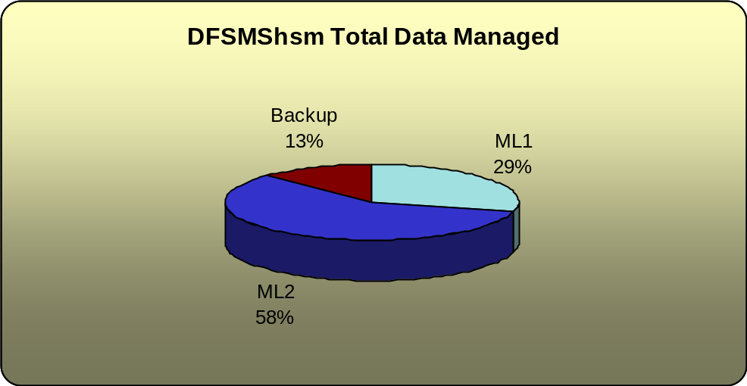

Migration and Recall Summary
Migration and recall activity is a significant piece of DFSMShsm functionality, and impacts system utilization. By analyzing Recall activity in various ways, a better determination may be made for tuning DFSMShsm performance and lowering overall system overhead.
This chart indicates DFSMShsm overall dataset movement activity. It is an indicator of the amount of work DFSMShsm is being asked to perform in managing data.
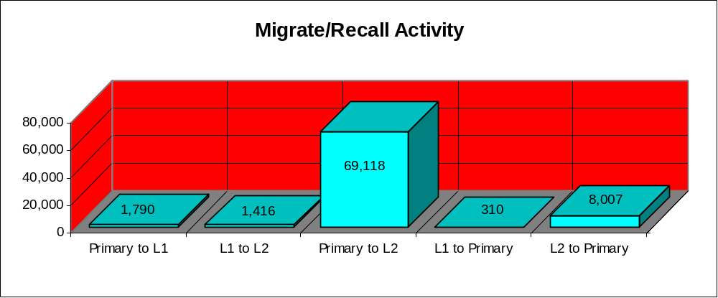
An area of DFMShsm that is often overlooked is the movement of data from primary to ML1 or even ML2. It’s possible that some datasets could remain on Primary a little longer.
IBM Tivoli Advanced Reporting for DFSMShsm uses a term called ‘thrashing’ which describes data sets that are regularly migrated and recalled. A thrashing index value of 0-9 is assigned, where 9 is the highest thrashing indicator. This thrashing index (TI) is calculated based on creation date and how many times the data has migrated.
Example:
- A data set that was created 2 weeks ago and migrated 2 times would be assigned a thrashing index value of 6.
- A data set that was created 1 week ago and migrated 3 times would be assigned a thrashing index value of 7.
- A data set that was created 3 weeks ago and migrated 8 times would be assigned a thrashing index value of 8.
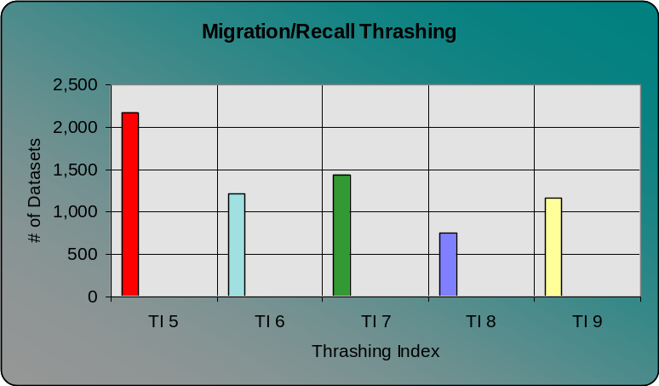
This chart displays the number of datasets that have a thrashing index of 5 or higher on the PROD system. These datasets should be looked at further to determine if they are assigned the proper MGMTCLAS within DFSMS. An alternative is to determine if the MGMTCLAS migration attributes are appropriate.

Migration and Backup Summary
By extracting information from the DFSMShsm log files, you can easily and quickly verify the overall ‘health’ of migration/backup and focus quickly on the most serious problems. The chart below depicts the amount of errors during migration/backup processing.

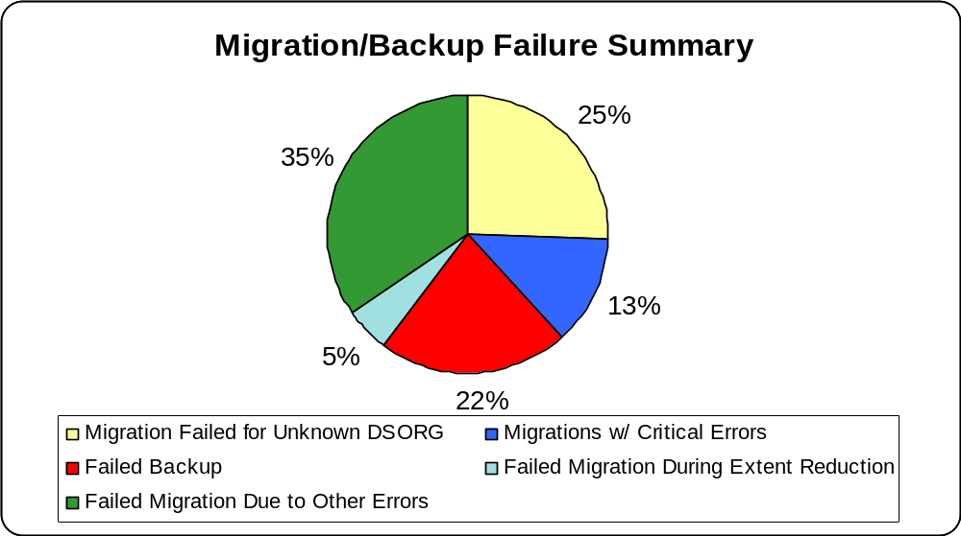
Data sets that have been migrated for 2 or more years are candidates for data archival using IBM Tivoli Advanced Backup and Recovery for z/OS (ITABR). Candidates are collected and grouped according to customer provided criteria and moved into an archive file to be retained for the appropriate amount of time. Archive files can be set to expire automatically or retained indefinitely. All data is accessible for reporting and recovery using ITABR. Removing inactive data from DFSMShsm reduces CDS Sizes, migration and backup volume requirements, and saves CPU and I/O processing during CDS backups, reorgs, recycle and tape copy activities.
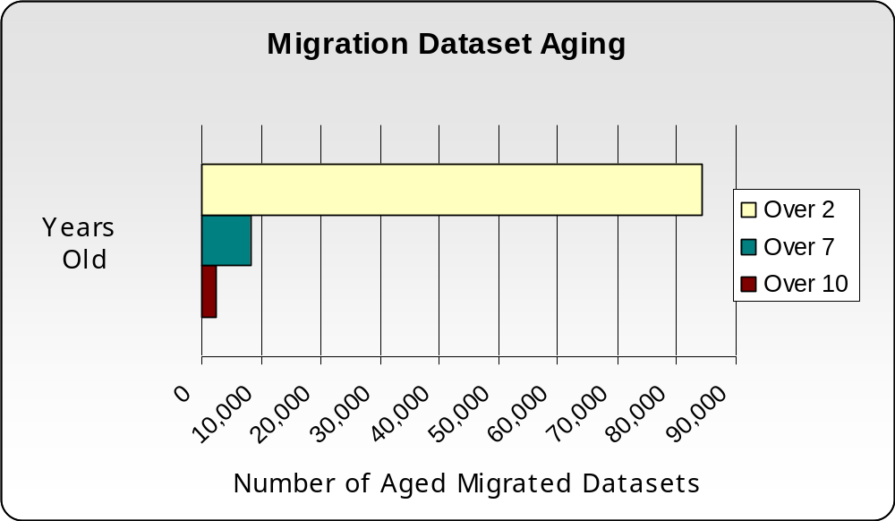

DFSMShsm Tape Utilization
This chart shows the tape utilization of DFSMShsm managed tape volumes in percentages. The greater number of higher percentage filled tapes, the better. By keeping tapes full, it eliminates unnecessary tape mounts and reduces resource consumption (CPU, channels, etc.) during recycle processing and provides a greater opportunity for finding a dataset stacked with others already being requested on a particular tape drive.

If you recycle your DFSMShsm tapes to reclaim tapes that contain 50% or less valid data, it will help to slow down the growth of your tape environment. If using virtual tape, staging under-utilized tapes wastes tape controller cache, stages invalid data and on average delays data access waiting for tape data staging.
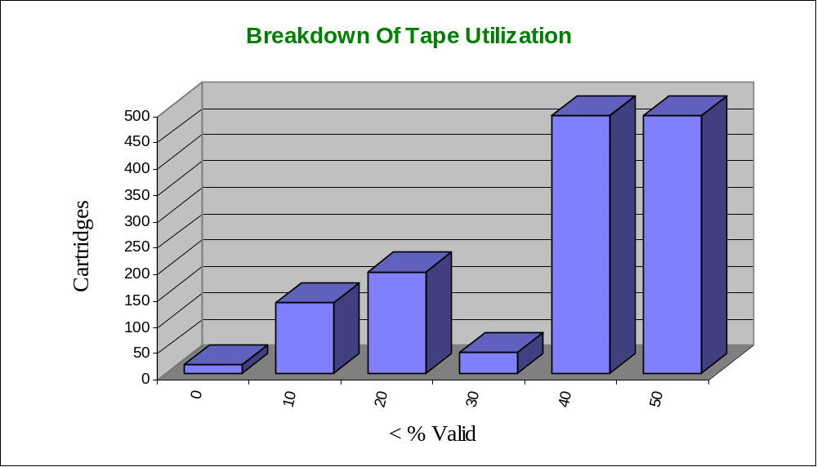

DFSMShsm Tape Summary
This chart shows the total DFSMShsm tape utilization by function in the ABC environment.

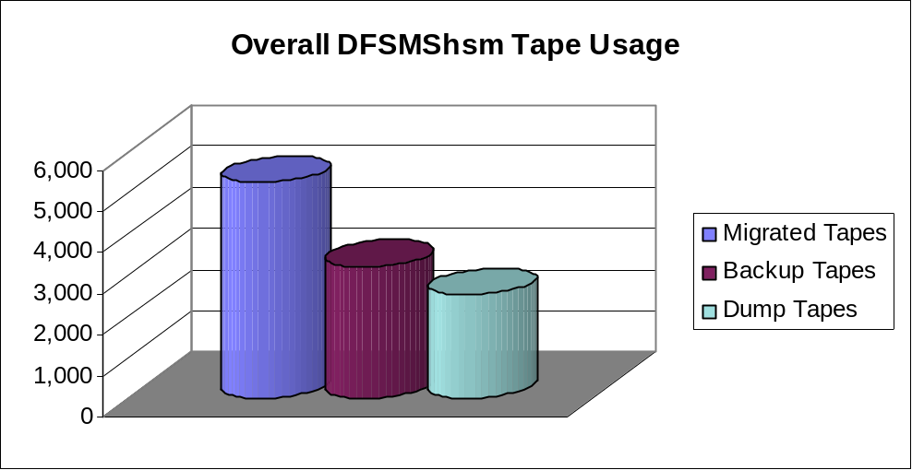

DFSMShsm Financial Overview
Data in DFSMShsm that has been inactive for over two years can be archived out of DFSMShsm and into ABARS Manager. The data is still available and recoverable but it is no longer managed by DFSMShsm and therefore does not incur the overhead of recycle, tape duplication, and results in a reduction in the virtual tape subsystem.
In addition, archiving old, inactive data out of DFSMShsm reduces the size of the control data sets used by DFSMShsm. This can result in a faster CDS backup and less system overhead by DFSMShsm.
The following section first determines the cost of CPU per dataset that DFSMShsm must use to manage the data. Based on this, that cost is then applied to the findings in the DFSMShsm analysis resulting in CPU savings.

Defaults
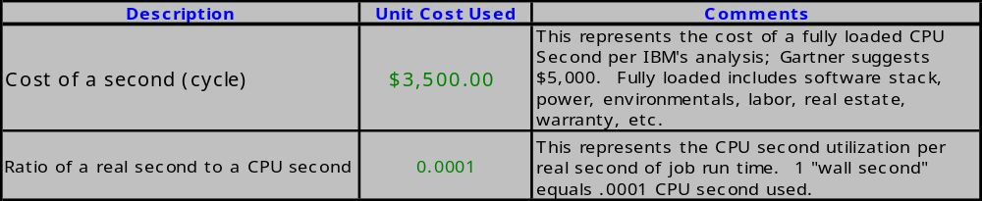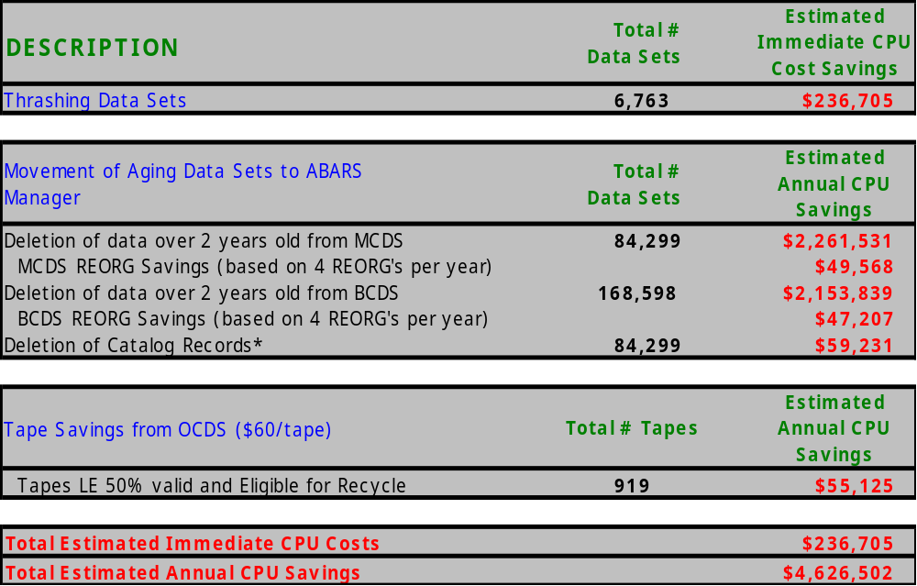The table below represents the default parameters used to determine the CPU cost analysis summaries for both the findings using IBM Tivoli Advanced Reporting for DFSMShsm and IBM Tivoli Advanced Audit for DFSMShsm. These numbers are “best estimate” by IBM or have been updated with numbers supplied by the staff at the ABC site being analyzed.
*Note: Catalog savings is due to a reduction in the CPU time it takes to backup the catalog.

DFSMShsm CDS Auditing
DFSMShsm Control Data Sets (CDSs) are the heart of the DFSMShsm system, which are used to manage and back up corporate data. The amount of data under the control of DFSMShsm can be as much as 80% of a corporation’s entire inventory.

These control data sets are part of the 'metadata' (a group of files that describe data). On a typical day many thousands of entries are created, altered or deleted from these metadata structures. During any of these activities, if a momentary DASD error, system crash, operational error, or code defect occurs; it could affect numerous data records. For reliable data access, the metadata must be accurate, self-consistent, and available.

Therefore, periodic audits of the DFSMShsm CDSs are recommended to ensure they are free of errors, thus improving data availability, reliability, and the general health of the system. DFSMShsm provides audit commands for this purpose, but due to high machine impact and the fact that it can take days or longer to run a single audit, these audits are seldom performed regularly.

Using IBM Tivoli Advanced Audit for DFSMShsm
DFSMShsm CDSs contain key information that is critical for data access and recovery. Should ABC need to recover data from a corrupted backup or migration record, there is a great possibility that the data would not be accessible or available in some instances. Also, the time to research and correct such an error could take hours.
By auditing the CDSs, using IBM Tivoli Advanced Audit for DFSMShsm, not only are errors found but fixes are automatically generated. By addressing and cleaning up these errors, you can ensure the integrity of the data managed by DFSMShsm and proactively resolve errors before they lead to data loss or failed access.
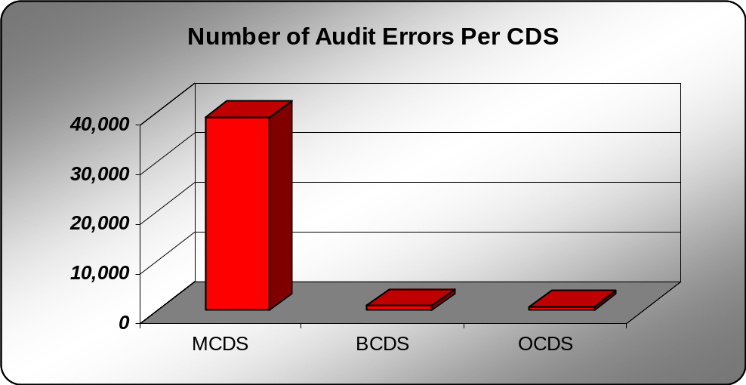The following chart represents a summary of ABC’s migration and backup errors on the PROD system.

CDS | % of Errors | # of Errors
MCDS | 96% | 38,952
BCDS | 3% | 1,043
OCDS | 1% | 581

MCDS Audit Summary
The MCDS contains information about migrated data. If this information is corrupted, access to the migrated data may be compromised and application jobs may fail. The audit of the MCDS is important as it performs a forward and backward audit of all the MCDS migration components and the ICF catalog entries that are cataloged to VOLSER MIGRAT.

- Number of data sets that have a high potential of inaccessibility (Critical) | 36,906
- Number of data sets that have a potential for inaccessibility, but corrective actions can be applied | 1,982
- Number of volumes that are in error and need immediate attention | 64

The critical errors found during the MCDS audit, indicate that 36,906 data sets can not be recalled. Below are a few scenarios as to why these are considered critical errors.
Scenario 1: Data sets are migrated but uncataloged, in which case the data sets would need to be recataloged, or perhaps the data sets are no longer needed and should be deleted.
Scenario 2: Data sets have been migrated but no migrated version of these data sets can be found. These data sets would have to be recovered from backup tapes, if such backups exist, quickly before the backup versions expire.
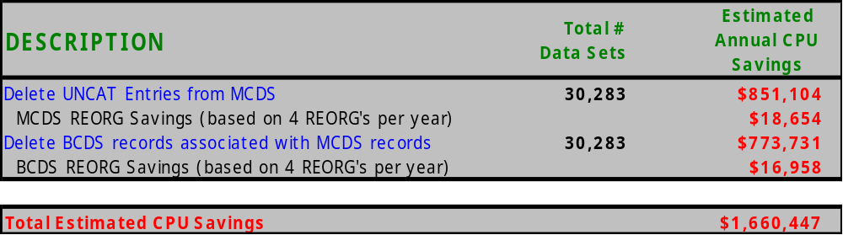Of the 36,906 critical errors, 30,283 entries can safely be deleted from the MCDS resulting in a reduction of the CPU time required to backup the catalog and REORG the MCDS. In addition, the backup (BCDS) records associated with these migration records would also be deleted, therefore reducing the spaces required and the CPU time it takes to REORG the BCDS.

BCDS Audit Summary
The BCDS contains a record of data set, volume and aggregate backup activity. Auditing the BCDS is just as critical as auditing the MCDS for insuring recoverability of corrupted or lost data.

- Number of back up versions that have a high potential to fail recover (Critical) | 1,008
- Number of record inconsistencies that have a potential to delay recycle, but corrective actions can be applied | 33

The critical errors found during the BCDS audit, indicate that 1,008 data sets can not be recovered from backup tapes. Below are a few scenarios as to why these are considered critical errors.
Scenario 1: Data sets have been backed up to an ML1 volume but have no VTOC entry for the DFSMShsm generated name. Therefore, the dataset cannot be recovered.
Scenario 2: Data sets have been backed up to an HSM backup volume but there is no BCDS volume record. The volume must exist in the BCDS before the volume can be mounted to recover the data. You would need to delete the backup version in error and create a new one.

OCDS Audit Summary
The OCDS contains information about data sets on tape for both backup and migrated data. The Tape Table of Contents (TTOC) record and its extensions are audited to ensure all pointers, forward and backward, are correct and all extension records are accounted for. This audit is necessary to ensure that the tapes in the OCDS inventory can recycle properly.

- Number of tapes that are not recyclable without taking corrective actions. (Critical) | 572
- Number of tapes that eligible for recycle | 476

The OCDS audit found 572 tapes that have critical errors that may prevent the tapes from being recycled. Below are a few scenarios as to why these are considered critical errors.
Scenario 1: Tapes are in ‘failed create’ status. Typically a tape is in failed create status if it was being written to when the system or DFSMShsm abnormally terminated. The only resolutions are to rebuild the missing records or recall/recover all active data on the tapes.
Scenario 2: For each volume in the OCDS, there is a field that indicates how many 16K blocks of data is currently active on the tape. If there is a mismatch, then recycle may bypass the tape when it should be recycled.
Scenario 3: Tapes that are 11 days old or older that have not been marked full may be of concern. These tapes will not be recycled since recycle operates on full tapes only. Tapes with this condition should be marked full such that they can be recycled and reclaimed for reuse.

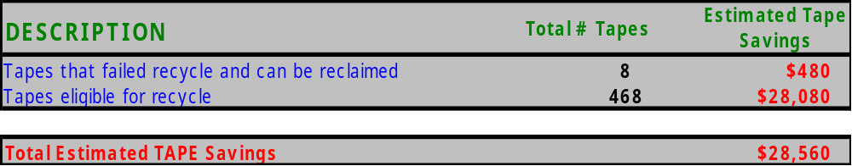The OCDS audit identified 476 tapes that may be reclaimed based on recycling tapes having failed recycle. A default value of $60 per tape is used in the following calculations. However, a disclaimer can be made that if these tapes reside within a virtual tape system, the tape savings will not be applicable.

Financial Summary
ABC can decide not to correct any reported errors and continue with business and plans as scheduled. However, it cannot be projected what and when corruption or problems may be encountered, but the business impact or outage could be disastrous and costly.

IBM’s product suite will help to reduce and even eliminate these costly financial exposures. By automating reporting and auditing, ABC can ensure data accessibility of all data regardless of where it resides thus saving time and resources.

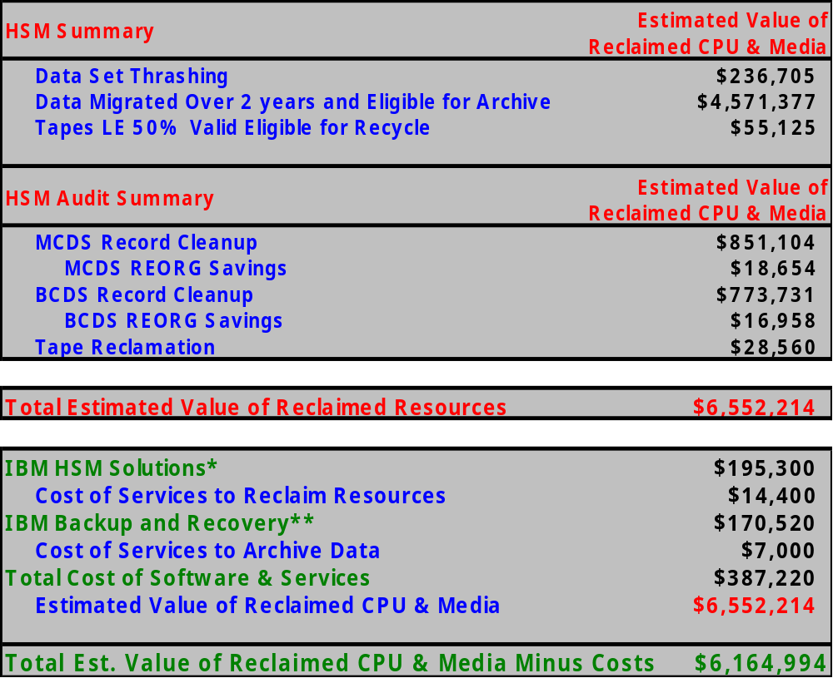Below is the financial summary which quantifies the cost of doing business as is and the cost of IBM’s product suite.

